The way we measure economies is inherently sexist

weforum.org/agenda/2016/04/why-economic-policy-overlooks-women

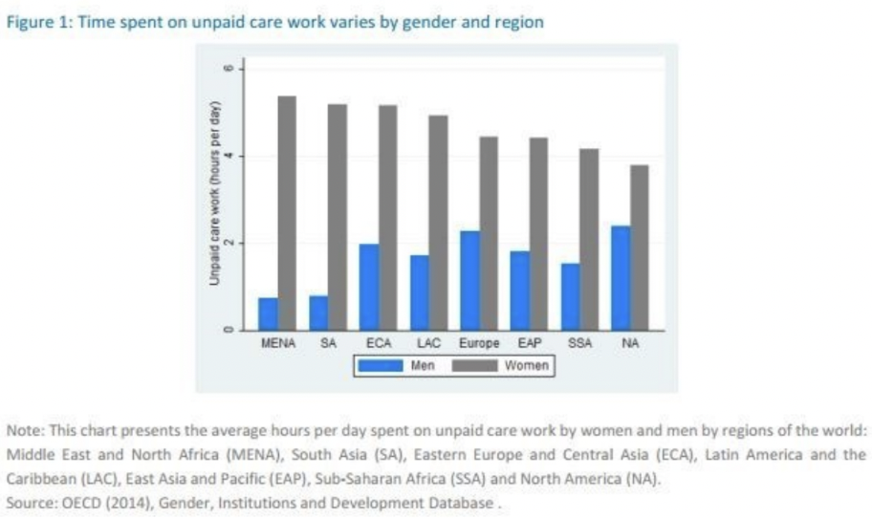

One headline indicator dominates public debate about the health or otherwise of the economy,

and that is growth in Gross Domestic Product (GDP).

It has become so familiar that few people appreciate that the creation and measurement of

GDP rests on many assumptions and judgments. These include two key omissions: changes

in environmental indicators; and unpaid work in the home and volunteering. Women do a

majority of this unpaid work (on average in the OECD countries women do about twice as

much, 150 minutes a day more, as men in the home). Because it is not measured, it is

generally overlooked by economic policy.

Image: 2014 OECD report, Unpaid Care Work

The omission of housework and caring (part of “home production” in the technical language) is

so familiar now that few people realise there was a vigorous debate about whether or not to

include it in GDP when the modern system of national income accounts was created in the

1940s.

In a classic history of economic measurement published in 1958, Paul Studenski pointed out

that over time, markets had developed for some household activities – such as restaurants for

meals out – and that women moved into the paid workforce during wartime then out of it again

afterward; hence, “The omission of unpaid services of housewives from national income

computation distorts the picture.” He concluded that in principle, unpaid work in the home

should be included in GDP, but there were practical difficulties in estimating the amount of

1/3

work and its valuation. Given that there are practical difficulties in every aspect of gathering

data to estimate GDP, it is hard to avoid the suspicion that in the end this just was not seen as

a sufficiently important question because it “only” concerned women and housework.

If women counted, GDP would look very different

Needless to say, feminists have long argued that (mainly) women’s unpaid work should be part

of what official economic statistics measure. One of the best-known contributions was Marilyn

Waring’s 1988 book, If Women Counted. But mainstream economics never entirely lost sight of

the issue either. In a well known alternative to GDP proposed in 1972 by William Nordhaus

and James Tobin, the “Measure of Economic Welfare” (MEW), their estimate for the amount

and value of “non-market production’ in the mid-1960s was equivalent to about 40% of

conventionally measured economic output economy. More recently, statisticians have

published occasional estimates. In a 2011 study, the OECD concluded that home production

would add between 20% and 50% to the GDP of its member countries. The US Bureau of

Economic Analysis said it would have added 26% to US GDP in 2010.

For all that there have been several initiatives to measure and incorporate unpaid work in the

home in the statistics for economic output, these have not had much traction in the policy

debate. This might be changing, however, for two reasons.

“The old barriers are breaking down”

One is that the amount of one kind of unpaid voluntary work is on the increase and is clearly

making a valuable economic contribution. That is the voluntary provision of free digital goods –

not “free” online content in fact paid for by selling personal data to advertisers, but genuinely

voluntary contributions. This includes widely used open source software such as Linux or R,

volunteer-maintained initiatives like Wikipedia or Ushahidi, and the proliferation of interesting

and entertaining blogs and videos.

The increase in digital volunteering means there is an unmeasured contribution to valuable

economic activity. More importantly, it blurs the clear boundary between “home” and

“economy” assumed in the conventional definition of GDP. People who provide such content

online might be doing some of it as part of a paid job, some as a hobby; or they might hope it

will turn into paid work later, or provide some marketed services using the free content as a

shop window. In any case, the old boundary is breaking down.

The recent report on UK economic statistics by Sir Charles Bean pointed out that there are

several ways the digital economy presents a challenge to conventional economic statistics, the

“production boundary” question among them. It is more than ironic that men do a majority of

this voluntary activity, in the male-dominated tech world, but the impetus it brings to measuring

all unpaid work is still welcome.

The second reason is that demographic trends in many countries (not all of them rich ones)

mean the decision by women about whether to work unpaid at home or for pay is increasingly

important for public policy. Who is going to care for the rapidly growing proportion of older

2/3

people? We will end up working longer on average, and medical researchers are paying more

attention to the health and vitality of people in their 60s and 70s; but even so the number of

very elderly people who need care is going to rise rapidly.

What are the policy options? Pay more – either through taxes to finance public provision or for

private provision – to support these older people. Invest in domestic “capital” such as robots for

cleaning or automated deliveries of meals. Or rely on unpaid caring from family members and

friends, a majority of it likely to be provided by women. There needs to be a debate about

which option or mix is desirable – and it should be informed by data. Until unpaid work in the

home is measured properly, this important policy debate is going to take place in ignorance.

“Distorted policies and perceptions”

The renewed interest in measuring women’s (and men’s) unpaid contribution to economic

activity is overdue – as is a parallel interest in measuring the unpaid contribution of nature to

our current consumption. Economists have a high regard for markets, not only because they

ensure supplies of goods and services are matched to demands in our complex globalised

economies, but also because they reflect individuals’ own preferences and choices. However,

the longstanding focus only on marketed activities through GDP has distorted perceptions and

policies.

As a rough guide to long run increases in prosperity, GDP growth has been a reasonable

yardstick; but it is only a proxy for economic welfare. There is no good rationale for continuing

to ignore other important components of economic well-being, including women’s unpaid work.

Some countries have made a start in collecting at least occasionally the data needed to

estimate an equal opportunity GDP, and the new technologies could make this easier. The

time has come now to reopen the 1950s debate about how we should define the economy,

and ensure that GDP or its replacement counts the vital work that goes on in the home, and in

the community, as well as work in the market.